## A blue and black text Description automatically generatedA close up of a sign Description automatically generatedLab 1 – Power Query M formula

**Creating Power Query M formula language queries.**

First of all, let’s just open the Power Query Editor if your Power BI Desktop appears as shown below-

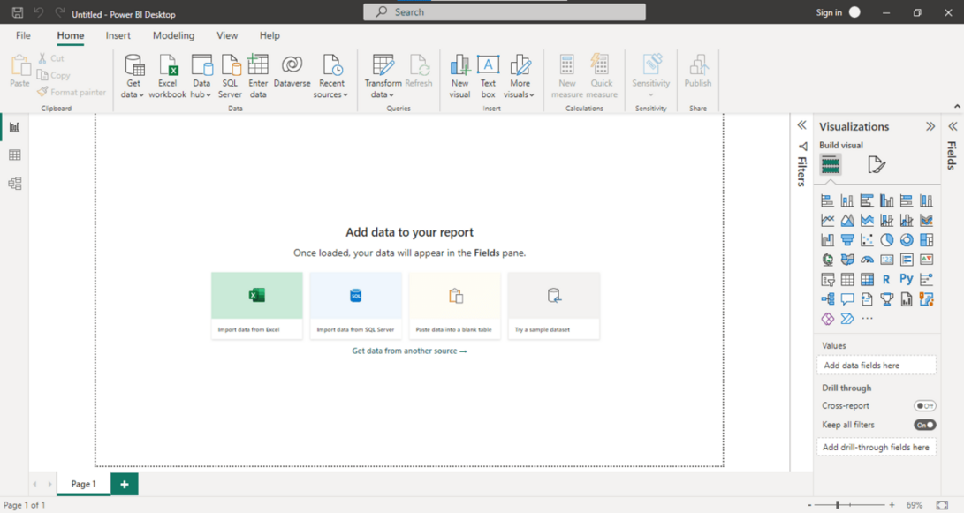

*Power Bi Desktop*

Go to Get Data tab or Recent sources, select the Dataset and click on “Transform Data”.

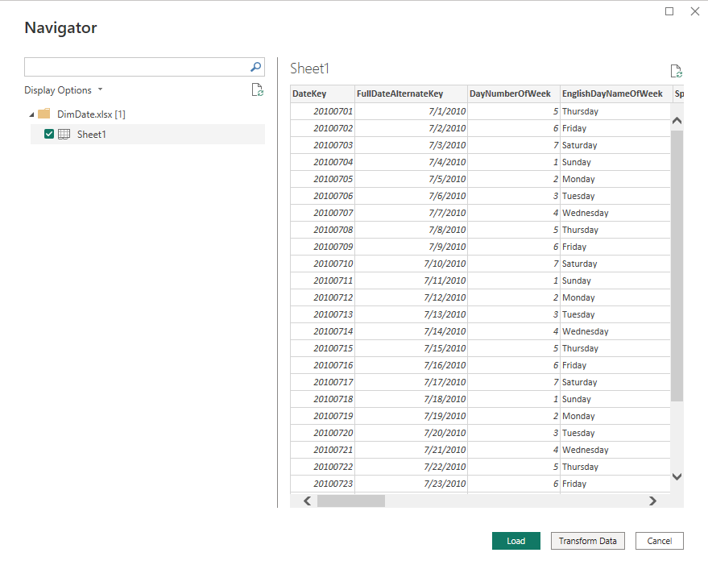

*Transform data.*

It will open a Power Query Window.

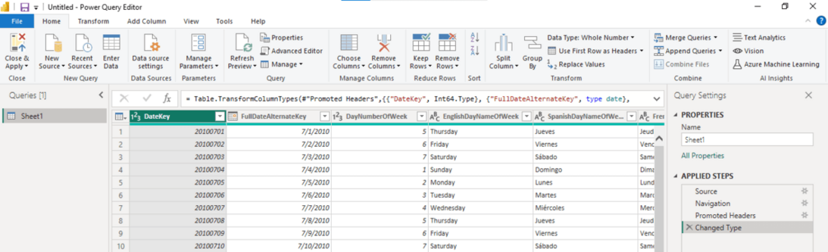

Power query is where the M language is written, and you can see on the right that these four stages were generated automatically.

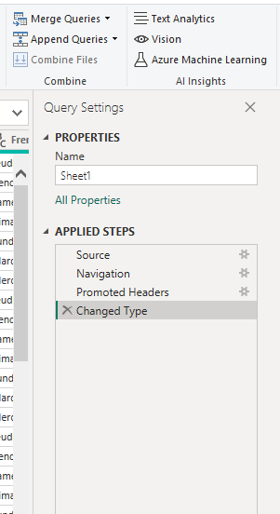

*Applied Steps*

Going forward, any modifications you make will be logged as steps. For example, if I select this column right click and remove other columns-

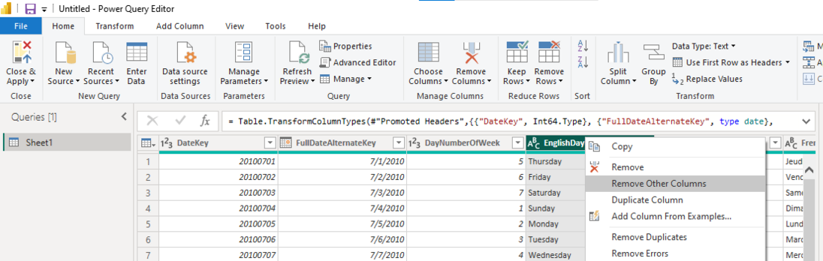

You see this step is generated here “remove other columns”.

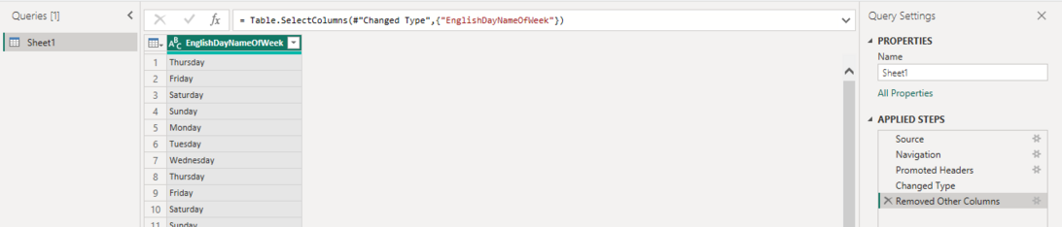

I may now change the case to lowercase. I’ll click on the This Format Lowercase button after choosing the Add Column Tab.

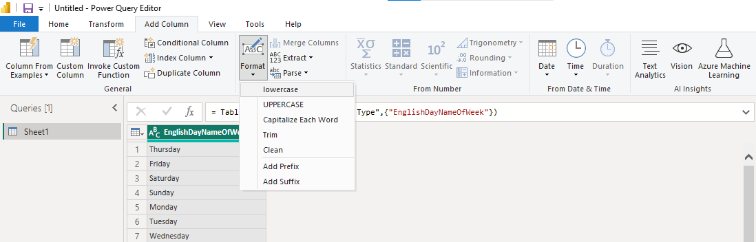

So, when I do so, you can see that the step “put it in lowercase” is generated once more. You can see the M function written here in the Table dot add column.

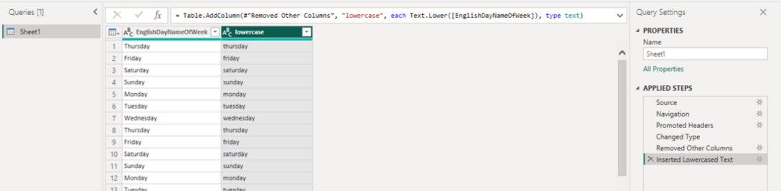

You can use the Query Editor to design complex queries. A let expression encloses the variables, expressions, and values that make up a mashup query. When referencing a variable, use the # identifier and the name enclosed in quotation marks, as in #”Variable name.”

This structure is followed by a let expression:

*let    
  Variablename = expression,    
  #”Variable name” = expression2    
in     
  Variablename*

In our case the Advanced query formed can be seen in Advance editor tab-



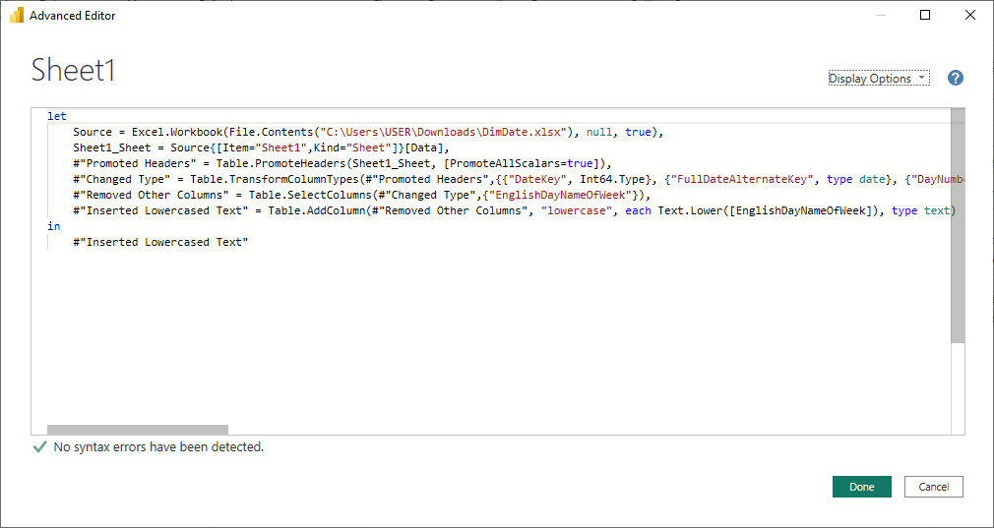

As a result, the procedures below can be broadly applied to creating a M query in the Query Editor:

* A series of query formula steps that begin with the let statement should be created. A step variable name identifies each phase. The # character can be used as #”Step Name” to incorporate spaces in a M variable. A formula step might contain a unique formula. Keep in mind that case matters while using the Power Query Formula Language.
* By referring to a step by its variable name, each query formula step builds on the one before it.
* Use the in statement to output a step from a query formula. The final query step result is typically utilized as the final data set result.